

Semester Two Examination, 2023

Question/Answer booklet

MATHEMATICS METHODS  
UNITS 3&4

Section One: Calculator-free

Your name

Your Teacher’s name

## Time allowed for this section

Reading time before commencing work: five minutes

Working time: fifty minutes

## Materials required/recommended for this section

***To be provided by the supervisor***

This Question/Answer booklet

Formula sheet

***To be provided by the candidate***

Standard items: pens (blue/black preferred), pencils (including coloured), sharpener,  
correction fluid/tape, eraser, ruler, highlighters

Special items: nil

## Important note to candidates

No other items may be taken into the examination room. It is **your** responsibility to ensure that you do not have any unauthorised material. If you have any unauthorised material with you, hand it to the supervisor **before** reading any further.

|  |  |  |  |  |  |
| --- | --- | --- | --- | --- | --- |
| Question | Mark | Max | Question | Mark | Max |
| 1 |  | 10 | 5 |  | 7 |
| 2 |  | 6 | 6 |  | 7 |
| 3 |  | 7 | 7 |  | 6 |
| 4 |  | 8 |

## Structure of this paper

|  |  |  |  |  |  |
| --- | --- | --- | --- | --- | --- |
| Section | Number of questions available | Number of questions to be answered | Working time (minutes) | Marks available | Percentage of examination |
| Section One: Calculator-free | 7 | 7 | 50 | 51 | 34.5 |
| Section Two: Calculator-assumed | 11 | 11 | 100 | 97 | 65.5 |
|  | | |  | **Total** | 100 |

## Instructions to candidates

1. The rules for the conduct of examinations are detailed in the school handbook. Sitting this examination implies that you agree to abide by these rules.

2. Write your answers in this Question/Answer booklet preferably using a blue/black pen.  
Do not use erasable or gel pens.

3. You must be careful to confine your answers to the specific question asked and to follow any instructions that are specific to a particular question.

4. Show all your working clearly. Your working should be in sufficient detail to allow your answers to be checked readily and for marks to be awarded for reasoning. Incorrect answers given without supporting reasoning cannot be allocated any marks. For any question or part question worth more than two marks, valid working or justification is required to receive full marks. If you repeat any question, ensure that you cancel the answer you do not wish to have marked.

5. It is recommended that you do not use pencil, except in diagrams.

6. Supplementary pages for planning/continuing your answers to questions are provided at the end of this Question/Answer booklet. If you use these pages to continue an answer, indicate at the original answer where the answer is continued, i.e. give the page number.

7. The Formula sheet is not to be handed in with your Question/Answer booklet.

Section One: Calculator-free 34.5% (51 Marks)

This section has**seven** questions. Answer **all** questions. Write your answers in the spaces provided.

Working time: 50 minutes.

Question 1 (10 marks)

1. Solve $\ln{(x-2)}=\ln{x}+2$.

(4 marks)

(b) Find the exact solution of $2^{x-3}=7$ and express your answer in terms of logarithms.

(3 marks)

(c) Show $\log_{3}5=\frac{ln5}{ln3}$.

(3 marks)

Question 2 (6 marks)

(a) Determine $\begin{matrix}dy \\ \overline{dx}\end{matrix}$ when

(i) $y=x^{3}+\cos\left(2x-3\right)$. (1 mark)

(ii) $y=\int_{2}^{x}{\underset{ }{\ln\left(t^{2}-3t\right)}}dt$. (1 mark)

(b) Determine $\begin{matrix}d \\ \overline{dx}\end{matrix}\left(x\ln\left(3x\right)\right)$. (2 marks)

(c) Hence, or otherwise, determine $\int{\underset{ }{(ln{(3x)}+5)}}dx$. (2 marks)

Question 3 (7 marks)

The time, in minutes, that Jake takes to serve a customer at the local supermarket follows a uniform distribution defined over the interval [2,8].

(a) Determine

(i) Jake’s expected checkout time.

(1 mark)

(ii) the variance of the time taken to serve a customer.

(2 marks)

(iii) the probability that he will take more than 6 minutes to serve a customer.

(1 mark)

(b) Given Jake has already spent 3 minutes serving a customer, find the probability he will take less than another 4 minutes to finish.

(3 marks)

Question 4 (8 marks)

A tank initially contains $24$ L of water. Let $V(t)$ be the volume, in litres, of water in the tank $t$ 
 seconds after it is ruptured, so that

$$V^{'}\left(t\right)=-\frac{10t}{t^{2}+4}, 0≤t≤20.$$

Determine

(a) $V'(4)$. (1 mark)

(b) $V''(4)$. (3 marks)

(c) $V(4)$. (4 marks)

Question 5 (7 marks)

The random variable $X$ takes the values 0, 1, 2, 3 only and its probability distribution is shown below.

|  |  |  |  |  |
| --- | --- | --- | --- | --- |
| $$x$$ | 0 | 1 | 2 | 3 |
| $$P(X=x)$$ | $$a$$ | $$b$$ | 0.05 | 0.15 |

(a) (i) Given that $E\left(X\right)=1.05,$ find the values of $a$ and $b.$

(3 marks)

(ii)Does $X$ have a binomial distribution? Justify your answer.

(2 marks)

(b) A binomial distribution for $Y\sim Bin (6, 0.7$) is shown below.

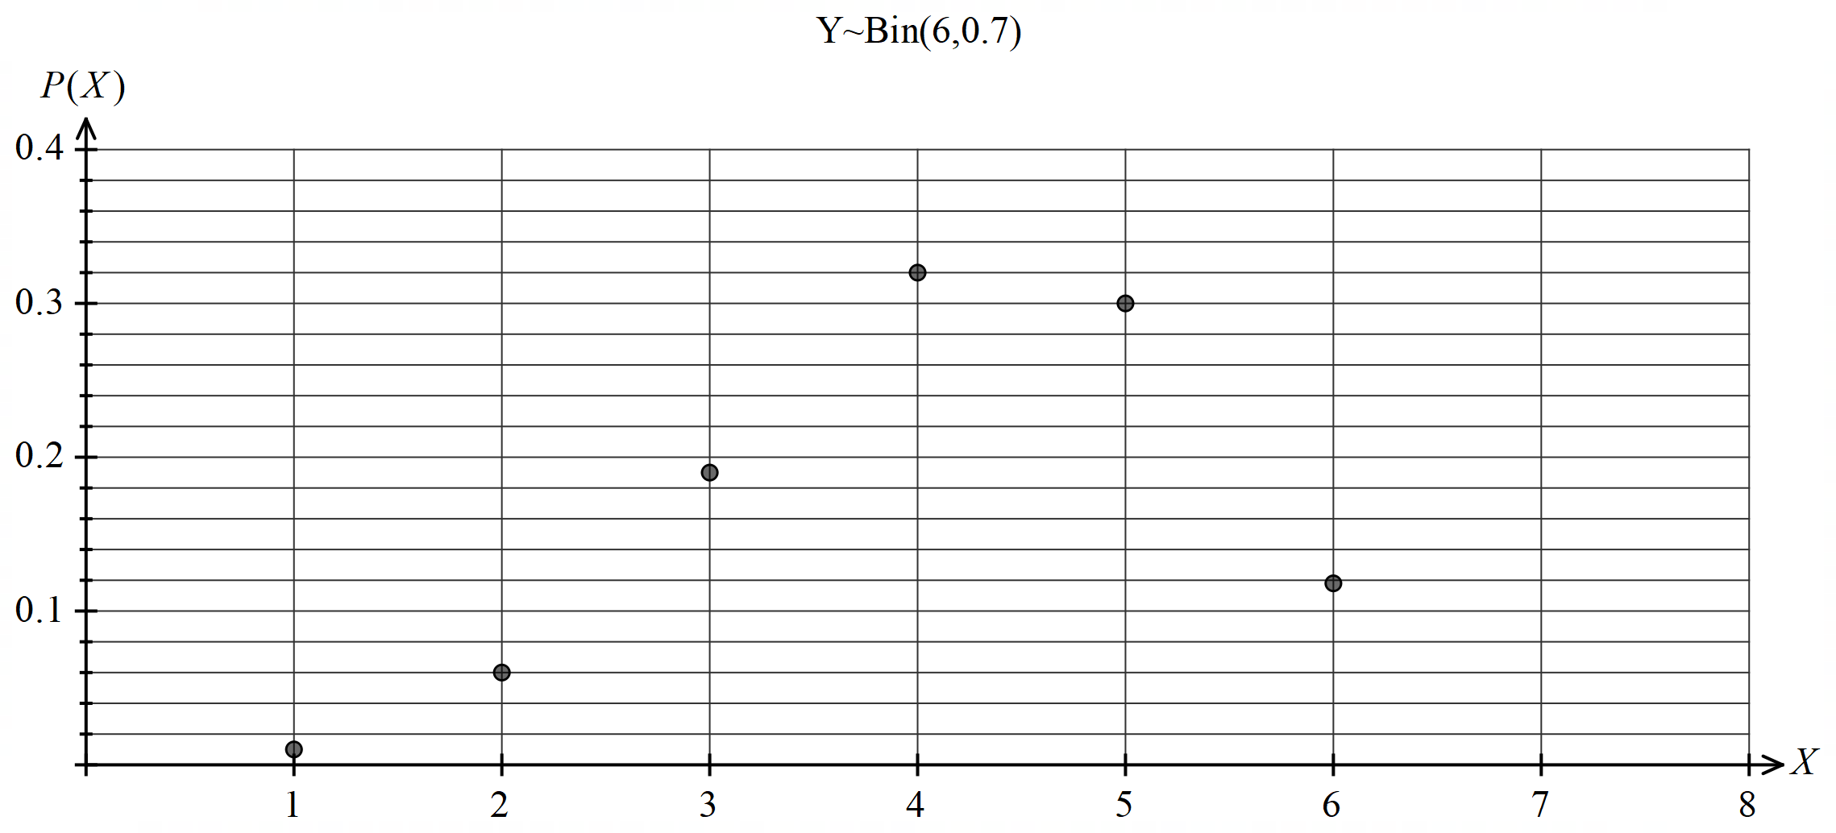

Draw the graph of $Z \sim Bin(6, 0.3)$ on the axes below.

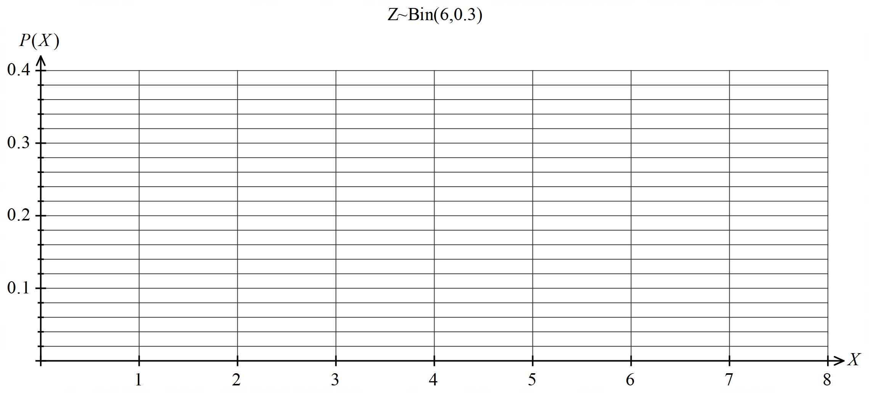(2 marks)

Question 6 (7 marks)

<EFOFEX>
id:fxd{3cd1aba3-5a5a-4487-9bdc-3d635db541f3}

FXData:
</EFOFEX>The graph of the curve $y=\sqrt{16-x}$ is shown  
to the right together with the chord $RS$ that  
joins the points of intersection of the curve  
with the axes.

(a) Determine the slope of the curve at $R$. (2 marks)

(b) Determine the area of the shaded region. (5 marks)

Question 7 (6 marks)

Part of the graph of $f\left(x\right)=\log_{a}{(x-b)}$, where $a>1$, is shown below.

<EFOFEX>

id:fxd{466d0a22-618e-4338-a8b6-feff5a462f79}


FXData:


</EFOFEX>

(a) State the value of $b$. (1 mark)

(b) Determine the value of $a$, given that the curve passes through $(e^{2}+e, 2)$. (2 marks)

(c) Using the **graph**, determine an **approximation** to the following definite integral: (3 marks)

$$\int_{3}^{9}{\frac{1}{x-e}}dx$$

Supplementary page

Question number: _________